**APPENDICES**

1. Curriculum Vitae
2. Endorsement Letter
3. Parent’s Waiver and Consent
4. Memorandum of Agreement
5. Certificate of Completion
6. Evaluation Sheet for Internship
7. Daily Time Record (Attendance Report)
8. Weekly Performance Report
9. Company Location Map
10. Company’s Organizational Chart
11. Photo Documentation
12. Other Supporting Documents

Appendix A

**Curriculum Vitae**

Appendix B

**Endorsement Letter**

Appendix C

**Parent’s Waiver and Consent**

Appendix D

**Memorandum of Agreement**

Appendix E

**Certification of Completion**

Appendix F

**Evaluation Sheet for Practicum**

Appendix G

**Daily Time Record (Attendance Report Summary)**

Appendix H

**Weekly Accomplishment Report**

Appendix I

**Company’s Location Map**

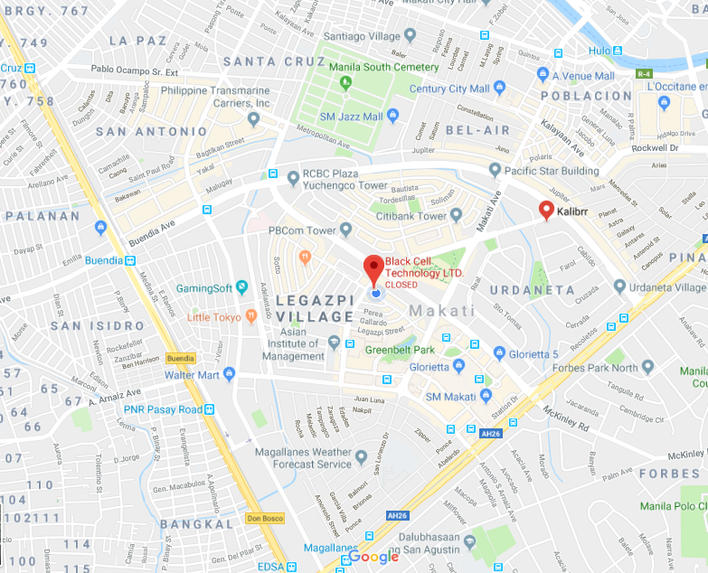

Appendix J

**Company’s Organizational Chart**

Appendix K

**Photo Documentation**

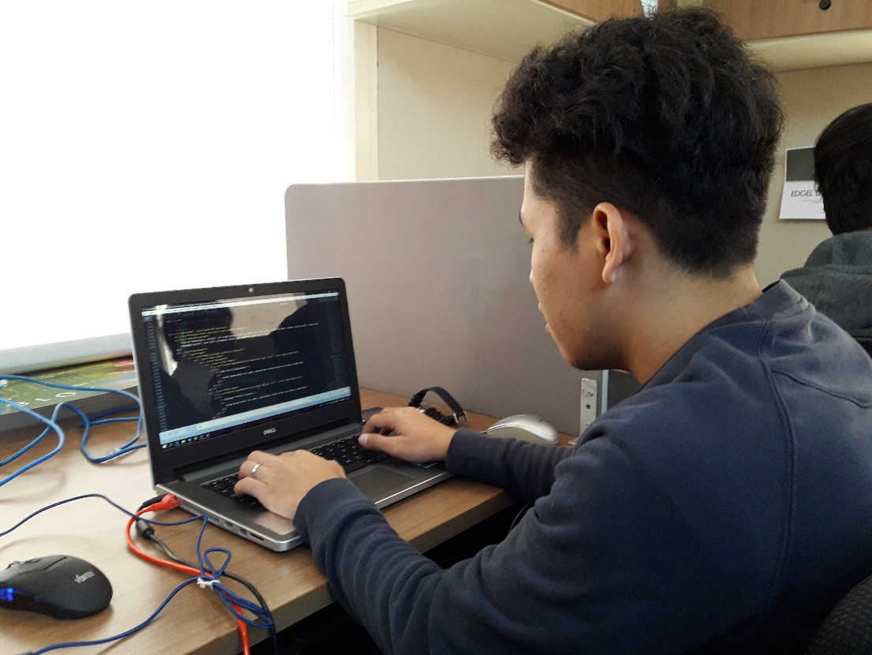

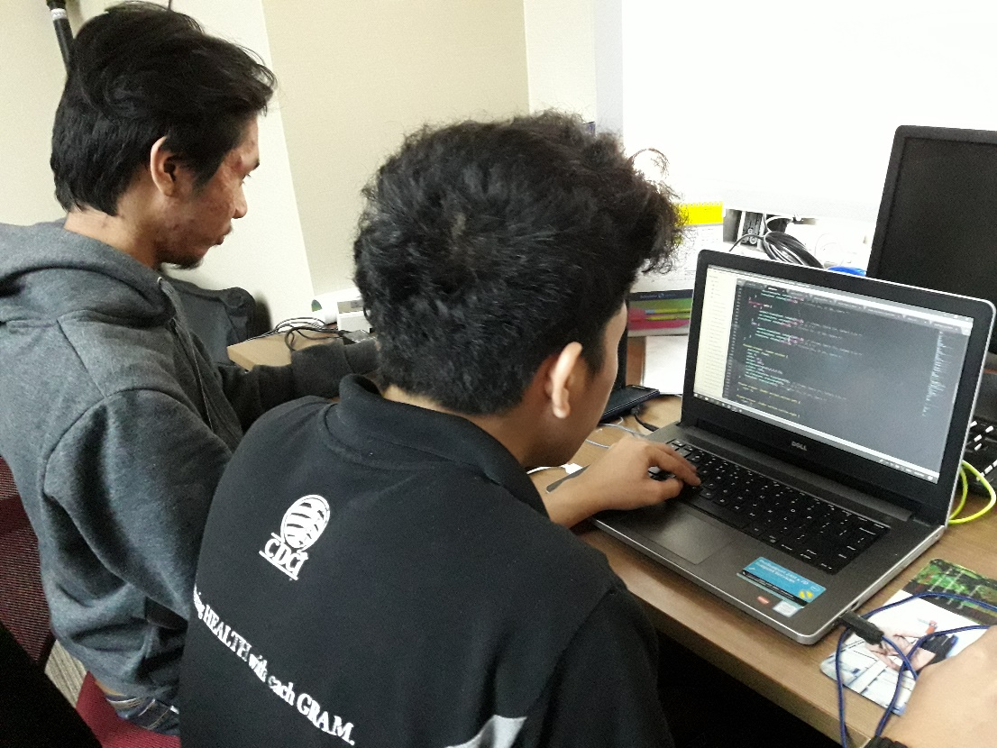

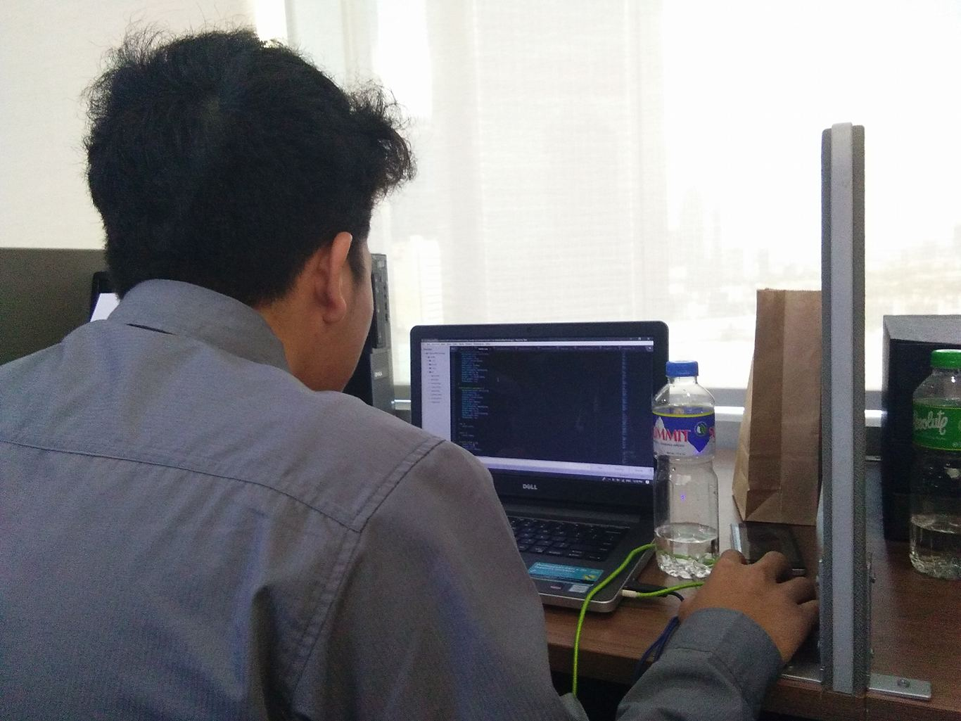

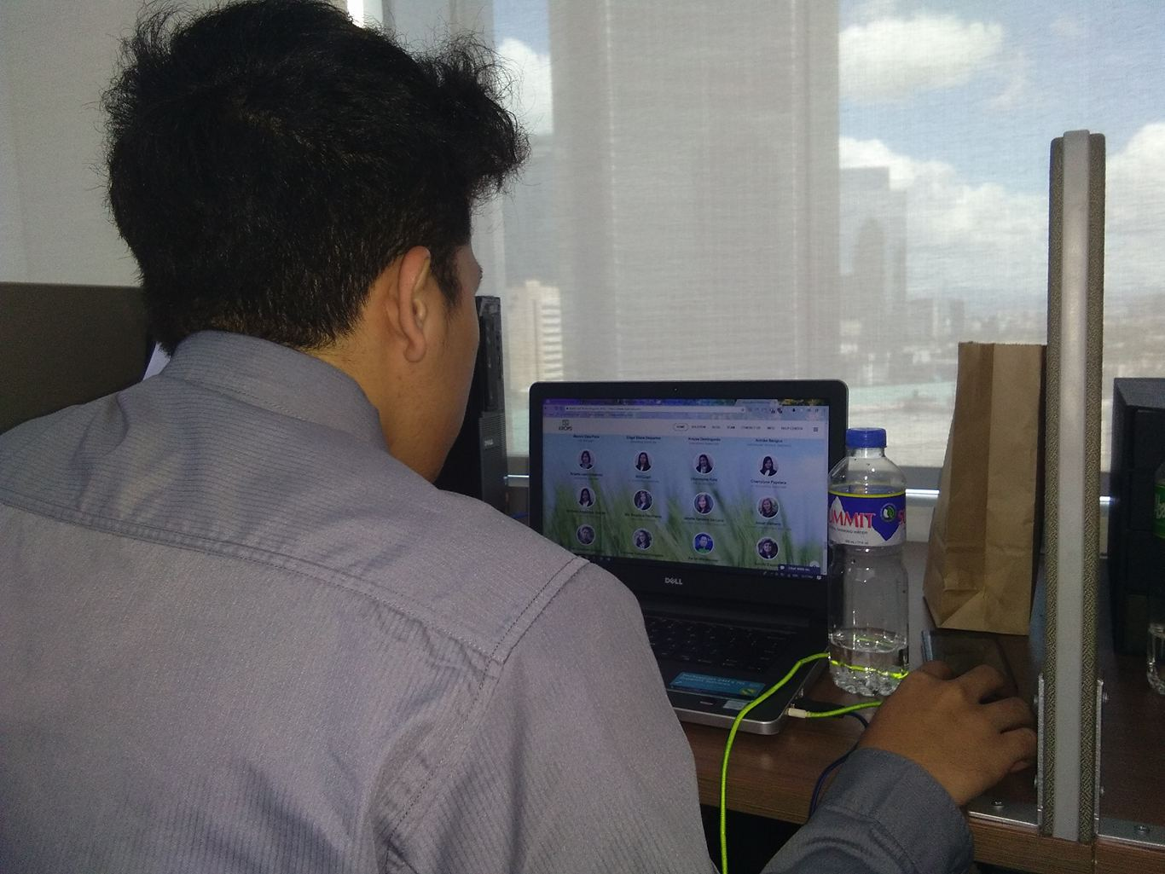



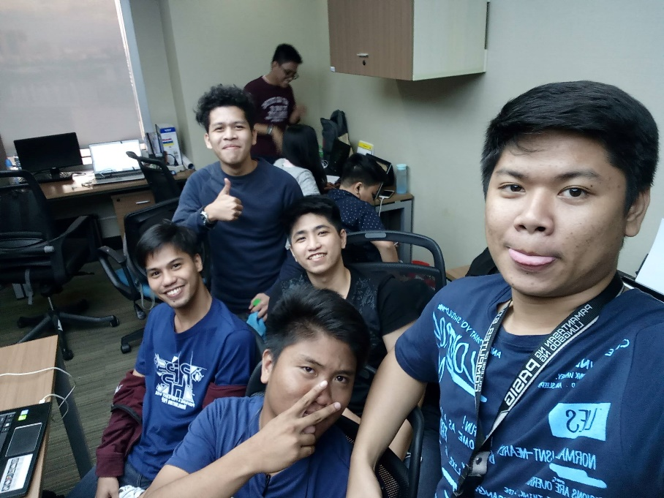

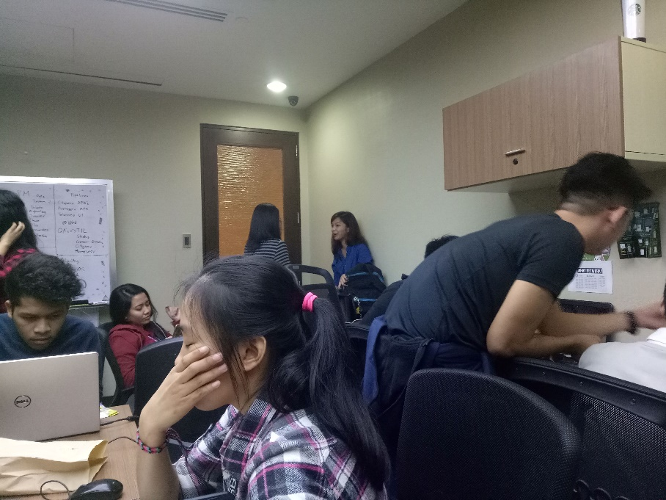

Appendix L

**Other Supporting Documents**